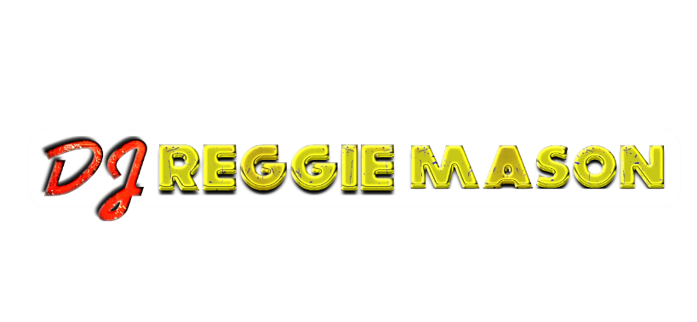 **reginaldmason@icloud.com * (615)596.6967**

**(Mobile Disc Jockey Contract)**

**Contracted DJ Services**

Between_______________________________, hereinafter referred to as the Purchaser, and By DJ Reggie Mason, hereinafter referred to as the DJ. Now Therefore, in consideration of the promises and the agreements herein contained and intending to be legally bound hereby, the Parties do agree as follows:

The Purchaser hires the DJ to provide DJ Services @ Event Type: _____________________________

**Location, Date and Time**

* Venue: _______________________ Date: __________________ Time: _________________

**DJ Services**

* DJ hereby agrees to provide DJ Services for the Purchaser at the above-mentioned location. The DJ Services shall consist primarily of providing musical entertainment by use of recorded music. The DJ Service will also include a microphone for DJ/Purchaser use. DJ agrees to arrive at the venue between 30 and 90 minutes prior to the start of the event for set up.

**Payment**

* The Purchaser agrees to pay: $100 per hour for DJ services. A minimum of 2 hours is required to secure DJ Services. Payment rate may vary based upon DJ and Purchaser agreement. Variables Include but are not limited to: Rental of additional sound/audio equipment. Use of additional entertainment lighting packages or accessories.

**Total Agreed Upon DJ Compensation for This Event**

* **$________**

**Signatures**

**DJ Reggie Mason:** Reggie Mason  **Purchase**r: _____________________________________

The purchaser and DJ agree that this contract is not subject to cancellation unless both parties have agreed to such cancellation verbally or in writing. In the event the Purchaser breaches the contract, he or she shall pay the DJ the amount set forth above as "Wage agreed upon". It is understood that if this is a "Rain or Shine" event, the DJ’s compensation is in no way affected by inclement weather. For outdoor performances, Purchaser shall provide overhead shelter for setup area. The DJ reserves the right, in good faith, to stop or cancel the performance should the weather pose a potential danger to him, the equipment, or audience. Every effort will be made to continue the performance. However, safety is paramount in all decisions. The DJ's compensation will not be affected by such cancellation. In order to prevent equipment damage or liability arising from accidental injury to any individual attending this performance, the DJ reserves the right to deny any guest access to the sound system, music recordings, or other equipment.